|  |  |
| --- | --- |
| Body counting at body foaming – SRP (IAL)  Modification Records | Abstract  This document contains a record of the modifications performed on the Refrigerator Body Counting system from V2 onwards and explains the reason for those changes  Abu Bakr Siddique  Digital Manufacturing and IT Engineering (MTO) |

Table of Contents

Focus **Error! Bookmark not defined.**

**Previous Version – V1** 2

**Current Version – V2** 4

# Enhancements in Body Foaming Section Operations

In our pursuit of operational excellence, the counting mechanism at the body foaming section has undergone a meticulous upgrade (V1 to V2). This upgrade addresses critical concerns:

1. **Streamlined Email Reporting:** Revamped email reporting ensures timely delivery of comprehensive reports to your inbox **now once a day instead of every hour**.
2. **Proactive Production Notifications:** A new notification feature alerts promptly when production falls below standard levels, facilitating swift corrective measures.
3. **Data Security During Power Fluctuations:** Robust measures safeguard against data loss during momentary blackouts, ensuring data integrity.

These refinements underscore the commitment to precision and efficiency, fortifying the counting system's resilience within the body foaming section.

## **Legacy Version – V1**

1. **Email Frequency and Format in V1:** In the initial version **(V1)**, emails were dispatched hourly, resembling the format depicted in Figure 1. This approach inadvertently mirrors the characteristics of typical spam emails. Notably, the final report contains data from the inception of operations at 8 am of the day, as illustrated in Figure 2.

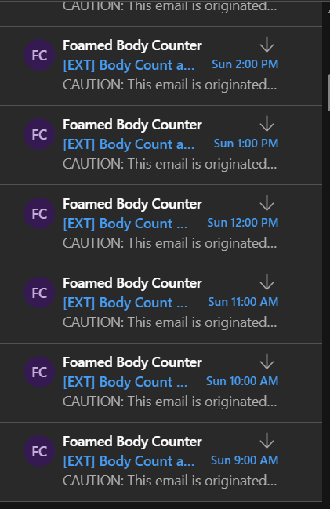

*Figure 1*. Inbox after receiving emails every hour

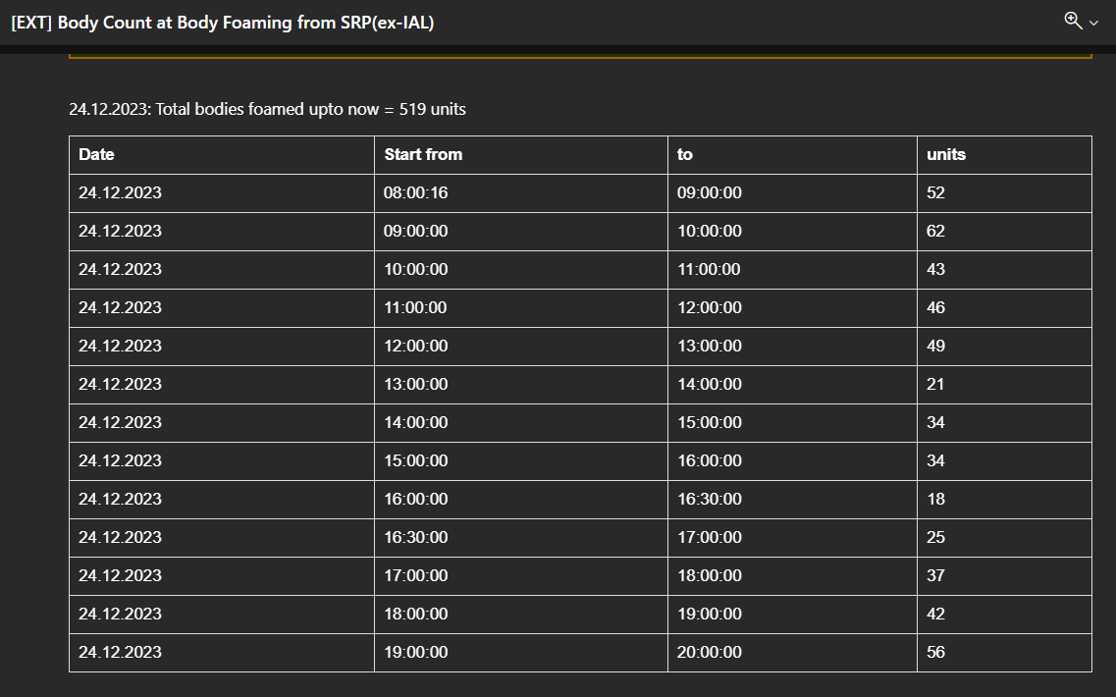

*Figure 2.* Last report of the day contains information from 8am

1. **Data Loss Consequences in V1:** Notably, V1's susceptibility to momentary power disruptions led to inaccuracies in recorded production quantities. For instance, a brief power loss at **2:36:16 pm** resulted in the **loss** of all refrigerator **body counts** from **2 pm to 2:36:16 pm**. The ensuing report (Figure 3) consequently depicted only units counted from 2:36:18 pm to 3 pm. To rectify this, the imperative need for a robust data retention system has been identified.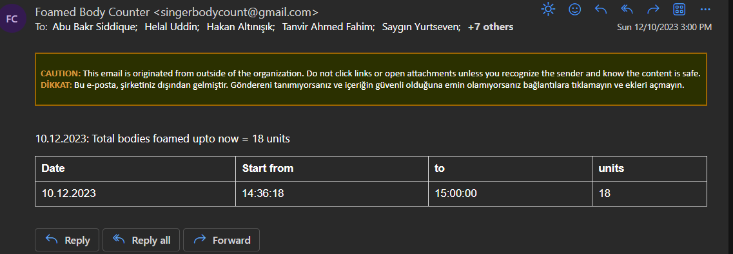

*Figure 3*. Effect of power loss on reporting

1. **Lack of Production Anomaly Alerts in V1:** Regrettably, V1 exhibited a shortfall in sophistication by not generating distinct notifications or reports in instances of inadequate production—specifically, when falling below the established threshold of 50-53 units per hour. This oversight underscores the system's limitation in intelligently discerning and alerting to deviations. A pressing remedy lies in the implementation of an astute alert system to rectify this deficiency.

## **Enhanced Version – V2**

Subsequent to the identification of the aforementioned concerns, notable modifications have been instituted in the system, involving a comprehensive update to both hardware and firmware, now designated as V2.

1. **Optimized Email Communication:** In V2, a strategic modification has been implemented to circumvent spam-related concerns. Now, all hourly production details will be consolidated into a singular email. Expect to receive a comprehensive summary at 4:30 pm daily, encompassing the production data from 7 am to 4:30 pm***.***
2. **Enhanced Data Resilience with Uninterruptible Power Supply (UPS):** A pivotal upgrade in V2 involves the integration of an Uninterruptible Power Supply (UPS) into the system's hardware shown in Figure 4. This fortification ensures uninterrupted data retention, eliminating any reporting discrepancies stemming from blackouts throughout the day, illustrated in Figure 5.

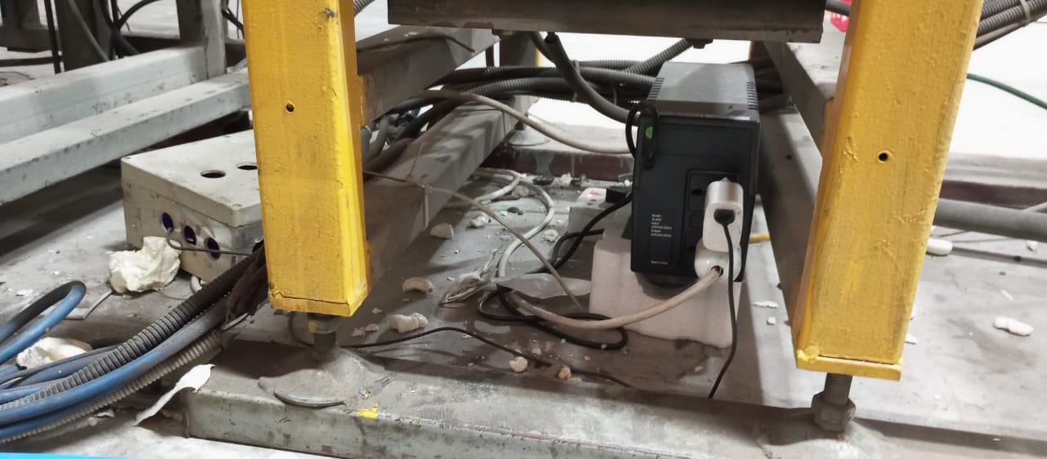

*Figure 4*. UPS integrated into the system

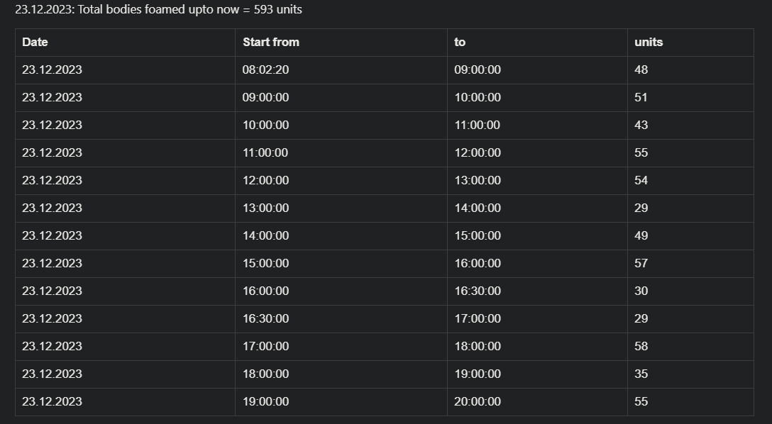

*Figure 5.* All the data for 23rd December, 2023 without any loss from blackouts.

1. **Proactive Alerts for Low Production:** In V2, a proactive approach has been adopted to notify pertinent production personnel of suboptimal output. Specifically, if production falls below 50 units in any given hour, an alerting email will be promptly dispatched. This strategic enhancement ensures timely response and intervention in instances of lower-than-expected production, illustrated in Figure 6.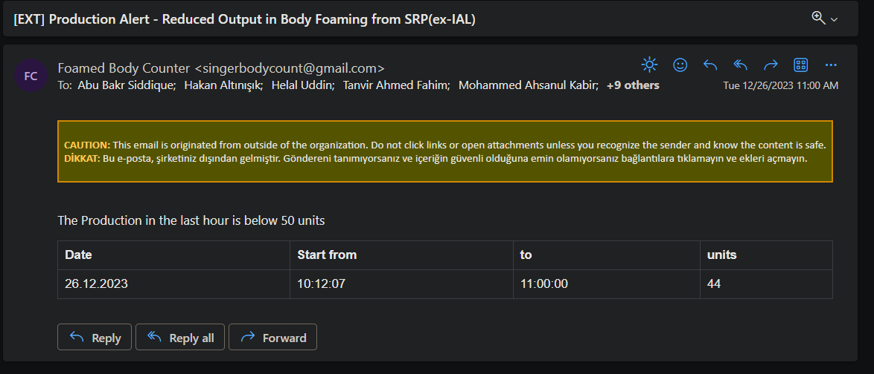

*Figure 6*. Alert for Suboptimal Production